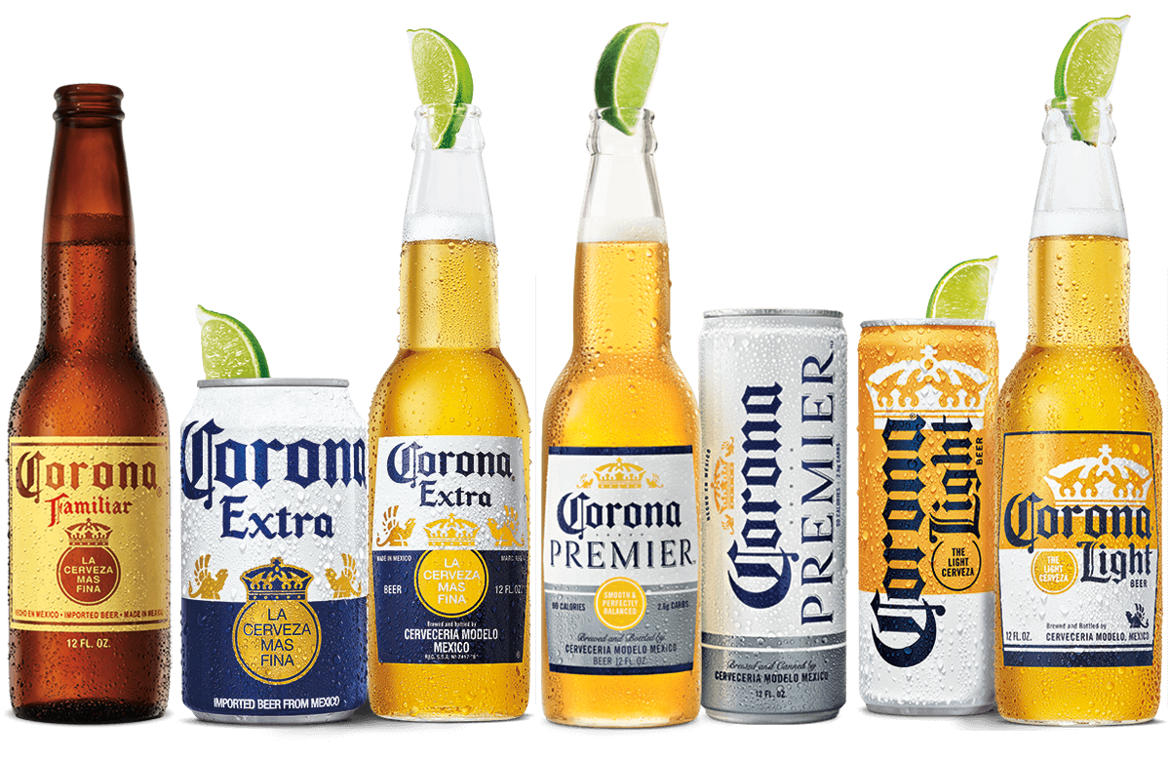

**Corona Familia 2020-2021**

|  |  |  |
| --- | --- | --- |
| **Sku** | **Item Name** | **Price** |
| 321842281 | Corona Hard Seltzer Variety - 12pk | 14.99 |
| 309623266 | Corona Extra - 6pk | 8.99 |
| 457026124 | Corona Familiar - 12pk | 14.49 |
| 420371396 | Corona Extra - 12pk | 14.49 |
| 487368350 | Corona Familiar - 6pk | 8.99 |
| 513148905 | Corona Extra - 4pk | 6.49 |
| 680055315 | Corona Familiar – 32 fl oz | 3.50 |

Please contact Steve Peacock ([speacock@abinv.com](mailto:speacock@abinv.com)) for additional details.